Collecting Geo Data

Months of 2022

Website/SEO Assignments

NAME: Tahiya Rahman

horizontal line

# About the Data

The data provokes NSTEM’s users and session times, increasing the probability of creating the driver for more leads. The data contains multiple time periods such as the whole month of November 2022 and December 18th to December 25th and a brief comparison of the last six months' data showed the highest number of users from different languages and countries.

# Comparison of Data over Different Time Periods

December 18th, 2022, to December 25th, 2022

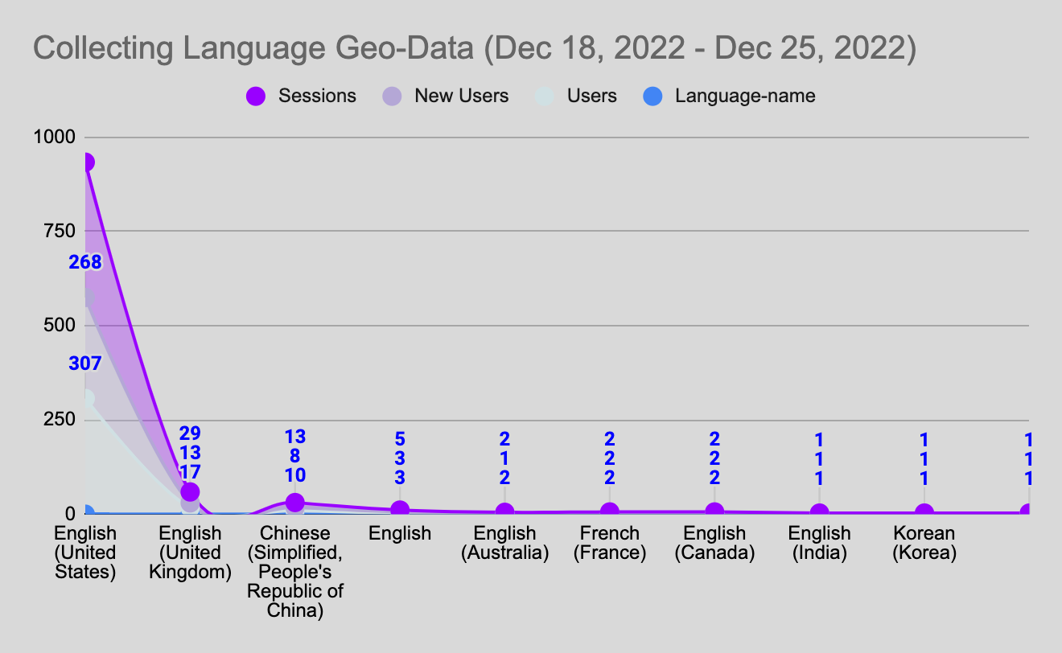

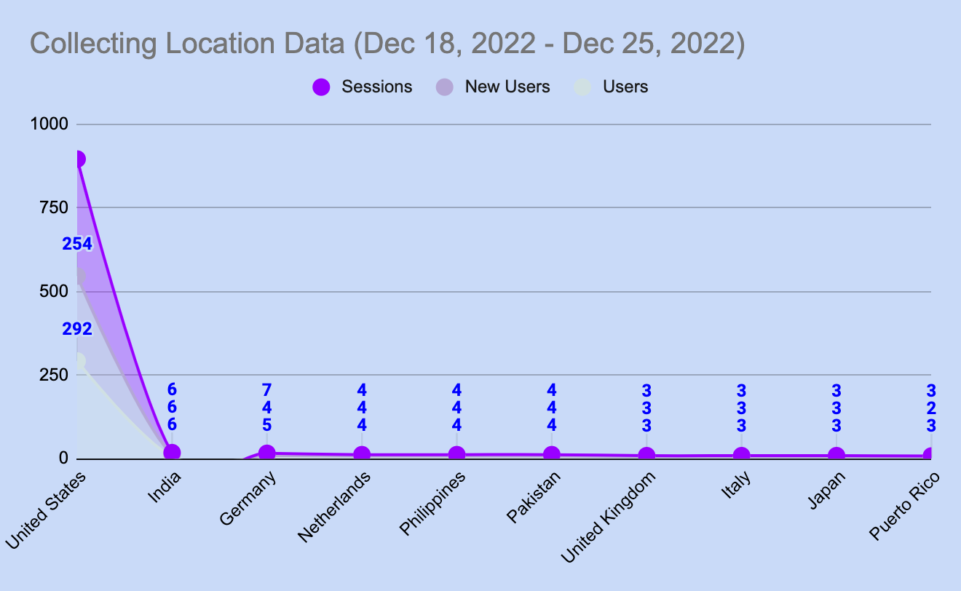

November 1st, 2022, to November 30th, 2022

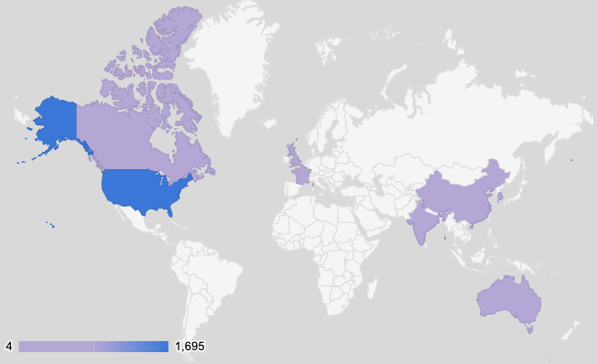 

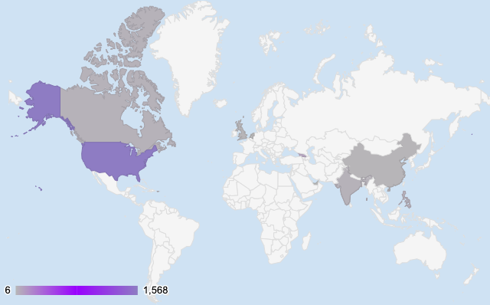

June 1st, 2022, to December 31st, 2022

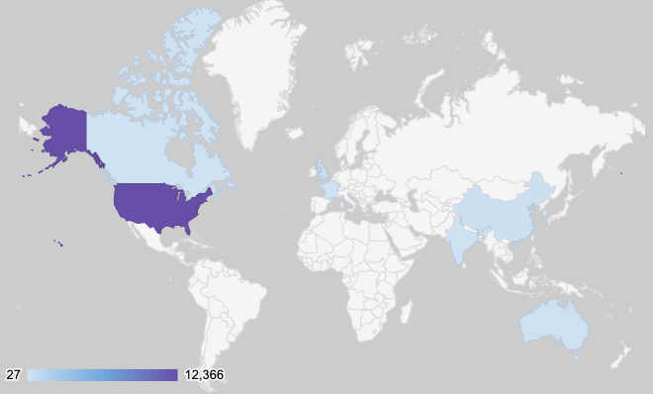

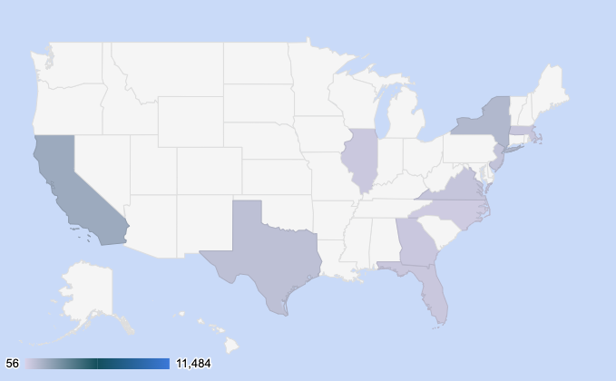

Data Studio: NSTEM at a glance from June 1st, 2022 to December 31st, 2022

# From the above data, as shown the highest lead generator countries in the last six months are the United States, the second United Kingdom, and the third China. There is a huge possibility to increase the new user base from the United Kingdom and China. Because these countries are also leading the sessions chart. When the students are investing more time in the websites, it can be their school system, and their interests are aligned with the NSTEM motives. Not only the lead generator countries but also website orientation can help to prevent the bounce rates for Spanish students and help students understand the insights of NSTEM.

# What NSTEM Should Continue Doing

* NSTEM should increase the number of student ambassadors/spokespersons.
* Post ads and pieces of information on a regular basis on social media to reach the desired audience base.
* Try promoting YouTube videos in different languages to attract students from different countries.

# Ways to Improve the Website

* As shown, NSTEM has a higher bounce rate. As a result, the audience is visiting the website and leaving without any insights. It can happen because of the unorganized search words which need to be checked.
* There can be other organizations like NSTEM or a similar name. An easier overview subsection can be helpful for the users to accomplish their goals.
* I was able to observe that the application form was too long and not easy to fill out. It needs a simple form layout where all the users can save time.
* NSTEM can create a mobile app, so the students and parents will be able to track their progress, pay the bills and get notifications.
* NSTEM should promote the website in a different language for the convenience of the parents and the children.
* The Internship page has issues where the apply option is not clear and it is above the comments sections.

# Data that Stands Out

According to the data from the last six months, the goal completion of the chapters is 1.6K. The number clearly proves the importance of the NSTEM career. But the bounce rate can be one of the issues where the students visit the website and leave without gaining any knowledge, seeking opportunities with other organizations. From the data, Spanish language users show the highest bounce rate. NSTEM can add the feature of a Multilingual Website where students all around the world will be benefitted.

# Conclusion

From the analysis of the last six months, November and December data, it has been observed that the majority of the users are accessing the site from the United States.

Google Sheets: <https://docs.google.com/spreadsheets/d/1aoLbyn7gFjz_M_0SSA0y8lG0aH5dI7brxNawSBgcfuc/edit#gid=2056166266>

Google data studio: <https://datastudio.google.com/reporting/5b7b7e81-7e31-4c00-a98f-b60028432c9b>

or

<https://datastudio.google.com/u/0/reporting/5b7b7e81-7e31-4c00-a98f-b60028432c9b/page/pubBD/appview?hl=en>